
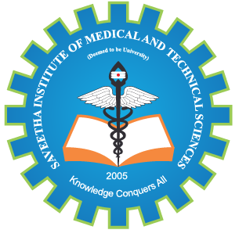
SIMATS ENGINEERING

Saveetha Institute of Medical and Technical Sciences
Chennai- 602105

Student Name: DHILIBAN M Reg. No.: 192421166
Course Code: CSA1522 Slot: C
Course Name: CLOUD COMPUTING AND BIG DATA ANALYTICS
Course Faculty: Dr Rajaram P
Project Title: Cloud-Based Identity and Access Management System with Federated Authentication
Module Photographs: (3 photographs –Module Photo, Individual student contribution module work in the project and presentation image)
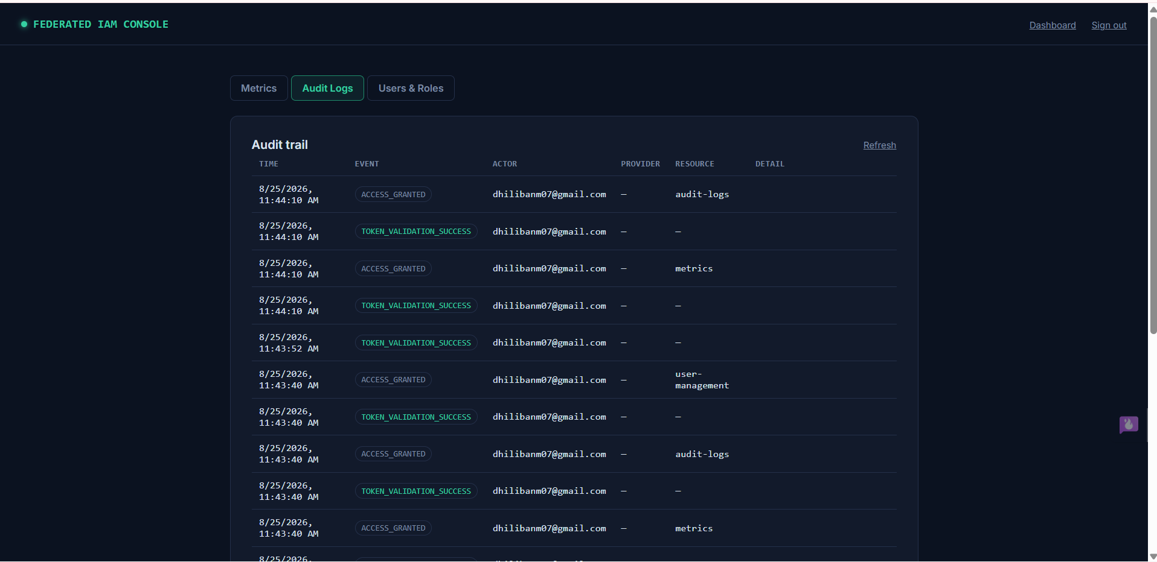
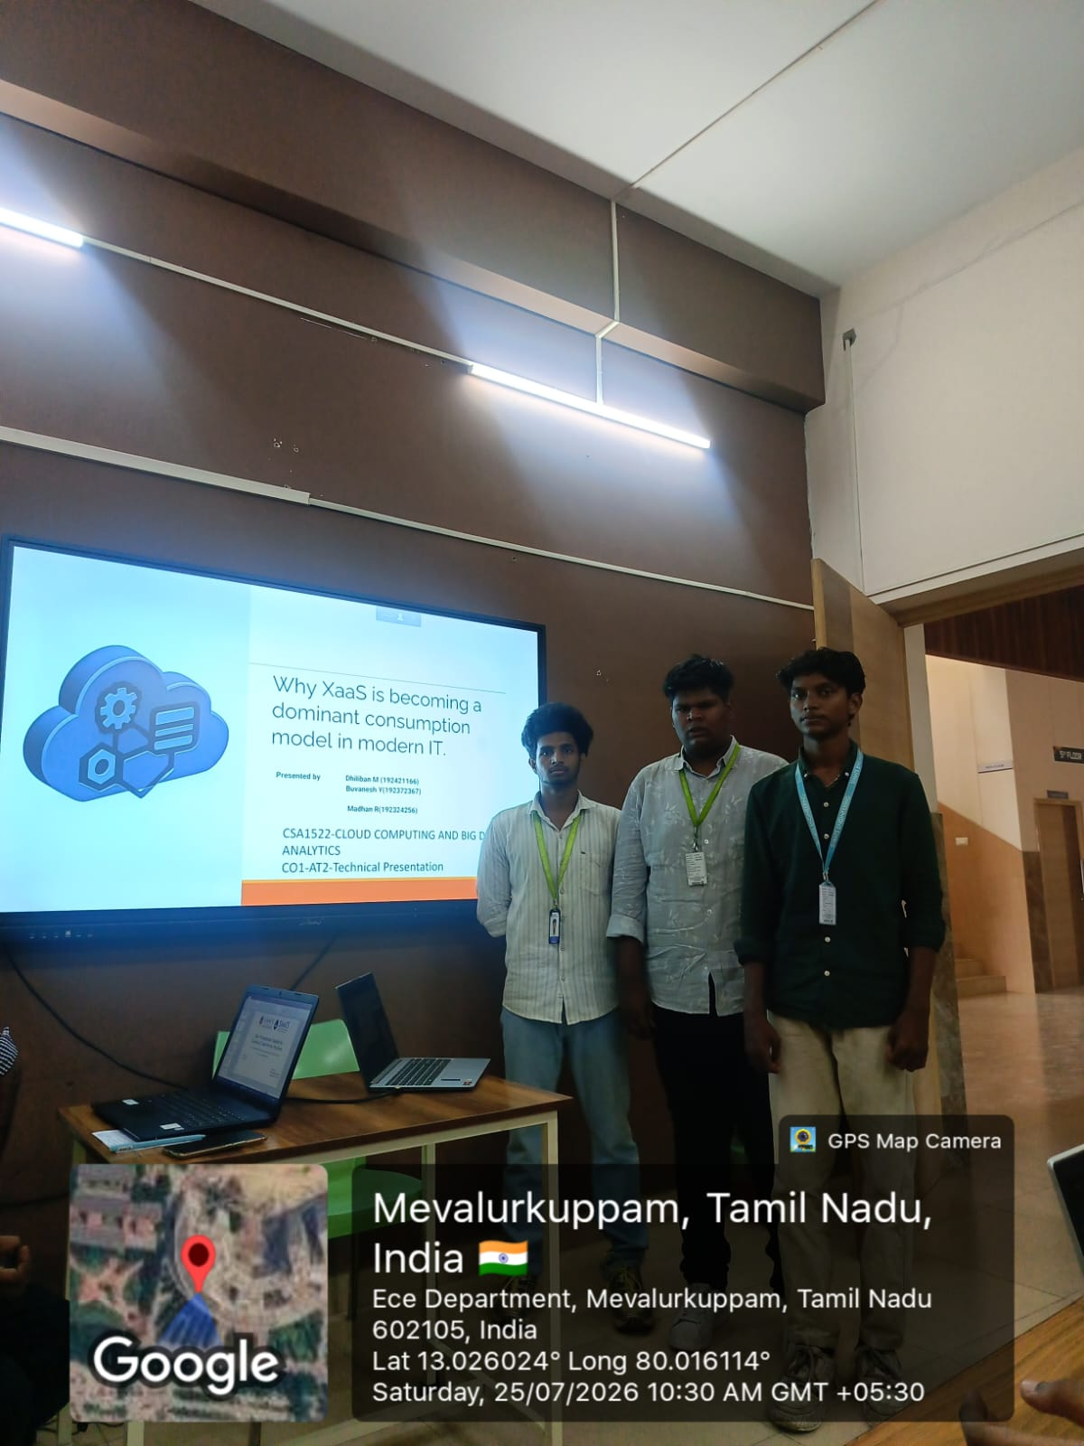
Project Description:
The Cloud-Based Identity and Access Management System with Federated Authentication is a secure cloud-based application designed to manage user identities, authentication, authorization, and access to multiple cloud-hosted services through a centralized system. The project provides users with a Single Sign-On (SSO) experience, allowing them to authenticate once and securely access multiple authorized applications without repeatedly entering their credentials.
The system implements OAuth2/SAML-based identity federation concepts with an identity provider such as Keycloak or Firebase Authentication. A centralized identity management component handles user credentials and authentication, while Role-Based Access Control (RBAC) determines which cloud services each user is permitted to access. After successful authentication, secure tokens are issued and validated when users request access to federated services.
The project consists of three major modules: User Identity & Credential Management, Federated Single Sign-On (SSO), and Access Policy Enforcement & Audit Logging. The system maintains user roles and access policies, validates authentication tokens, enforces permissions, and records important security events through centralized audit logs.

Student Signature Guide Signature

